Assignment Kit for
Program 8

Personal Software Process (PSP) for Engineers: Part II

The Software Engineering Institute (SEI)
is a federally funded research and development center
sponsored by the U.S. Department of Defense and
operated by Carnegie Mellon University.

This material is approved for public release.
Distribution limited by the Software Engineering Institute to attendees.

Personal Software Process for Engineers: Part II
Assignment Kit for Program 8
Overview

Overview | This assignment kit covers the following topics.
 | Section | See Page
 | Prerequisites | 2
 | Program 8 requirements | 3
 | Multiple regression | 5
 | Using multiple regression in the PSP | 6
 | A multiple regression example | 7
 | The gauss method | 9
 | Assignment instructions | 13
 | Guidelines and evaluation criteria | 22
 | Operational specification template and instructions | 23
 | Functional specification template and instructions | 25
 | State specification template and instructions | 27
 | Logic specification template and instructions | 29

Prerequisites | None

Program 8 requirements

Program 8 requirements | Using PSP2.1, write a program to calculate the three-variable multiple-regression estimating parameters (β₀, β₁, β₂, β₃).  Make an estimate from user-supplied inputs, and determine the 70% prediction intervals for the estimate.  Thoroughly test the program. Test the program using the data in Table 1 as the historical data. For the user inputs, use 185 LOC of added code, 150 LOC of reused code, and 45 LOC of modified code.  Expected values are included in table 2.

Prog. # | Added LOC | Reused LOC | Modified LOC | Hours
 | w | x | y | z
1 | 345 | 65 | 23 | 31.4
2 | 168 | 18 | 18 | 14.6
3 | 94 | 0 | 0 | 6.4
4 | 187 | 185 | 98 | 28.3
5 | 621 | 87 | 10 | 42.1
6 | 255 | 0 | 0 | 15.3
Table 1

Test | Parameter | Expected Value | Actual Value
Table 1 | β₀ | 0.56645
 | β₁ | 0.06533
 | β₂ | 0.008719
 | β₃ | 0.15105
 | Projected Hours | 20.76
 | UPI (70%) | 26.89
 | LPI (70%) | 14.63
Table 2
Continued on next page
Program 8 requirements, Continued

Program 8 requirements | Additionally, test the program using the data in Table 3, as the historical data. For the user inputs, use 650 LOC of added code, 3000 LOC of reused code, and 155 LOC of modified code.  Expected values are included in Table 4.

Prog# | Added LOC | Reused LOC | Modified LOC | Development Hours
 | w | x | y | z
1 | 1,142 | 1,060 | 325 | 201
2 | 863 | 995 | 98 | 98
3 | 1,065 | 3,205 | 23 | 162
4 | 554 | 120 | 0 | 54
5 | 983 | 2,896 | 120 | 138
6 | 256 | 485 | 88 | 61
Sum | 4,863 | 8,761 | 654 | 714
Table 3

Test | Parameter | Expected Value | Actual Value
Table 3 | β₀ | 6.7013
 | β₁ | 0.0784
 | β₂ | 0.0150
 | β₃ | 0.2461
 | Projected Hours | 140.9
 | UPI (70%) | 179.7
 | LPI (70%) | 102.1
Table 4

Multiple regression

Overview | Suppose that you had the following data on six projects.  - development hours required  - added, reused, and modified LOC  Suppose now that you want to estimate the hours for a new project that you judged would have 650 LOC of added code, 3,000 LOC reused code, and 155 LOC of modified code.  How would you estimate the development hours and the prediction interval?  The answer is multiple regression. Multiple regression is necessary when you have combined data for several different categories of work and you cannot separate them. You have total development times for each program, but no way to determine how many hours were spent on new development, reuse, or modification. This is a common problem since it is generally impractical to separately measure the time spent in each such category of development work.
Continued on next page
Multiple regression, Continued

Using multiple regression in the PSP | - Use the following multiple regression formula to calculate the project value.  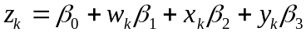  - Find the Beta parameters by solving the following simultaneous linear equations.  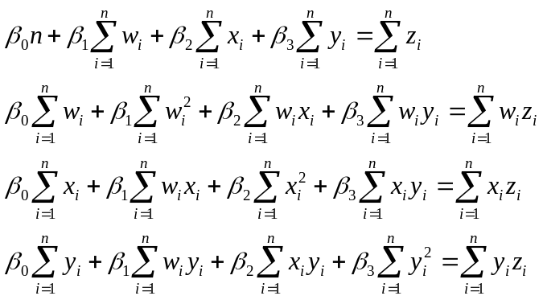  - Solve these equations with the standard algebraic methods that are used for simultaneous linear equations. Gaussian elimination procedure provides a structured way to do this. The multiple regression prediction interval is determined with the following equations, using dof = n-4 degrees of freedom.  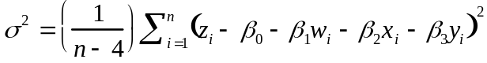  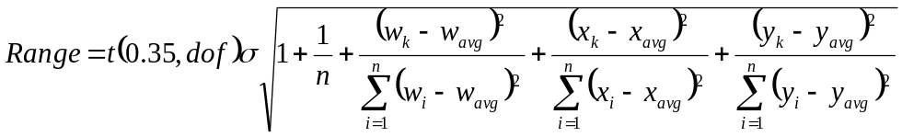

A multiple regression example

A multiple regression example | In this example, we’ll calculate the regression parameters and predictions range using the historical data in the table below. We’ll then use the regression parameters and predictions range to estimate the hours for a new project that is judged to have 650 LOC of added code, 3,000 LOC reused code, and 155 LOC of modified code.

Prog# | Added LOC | Reused LOC | Modified LOC | Development Hours
 | w | x | y | z
1 | 1,142 | 1,060 | 325 | 201
2 | 863 | 995 | 98 | 98
3 | 1,065 | 3,205 | 23 | 162
4 | 554 | 120 | 0 | 54
5 | 983 | 2,896 | 120 | 138
6 | 256 | 485 | 88 | 61

- Find the Beta parameters by solving the following simultaneous linear equations.

- When you calculate the values of the terms, you get the following simultaneous linear equations.
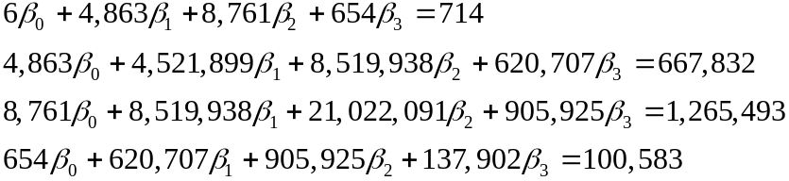

- Diagonalize, using Gauss’ method. This successively eliminates one parameter at a time from the equations by successive multiplication and subtraction to give the following.
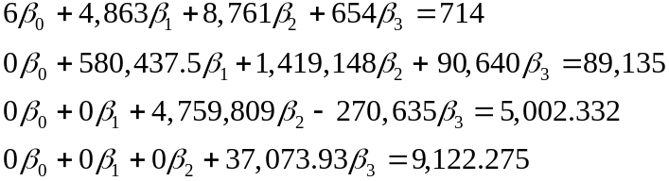
Continued on next page
A multiple regression example, Continued

A multiple regression example, continued | - Solve for the Beta terms.  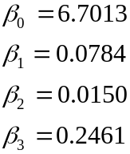  - Determine the prediction interval by solving for the range with the following equation.  - Calculate the variance as follows.  - The standard deviation evaluates to the following.  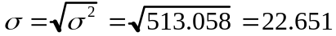  - The terms under the square root are as follows.  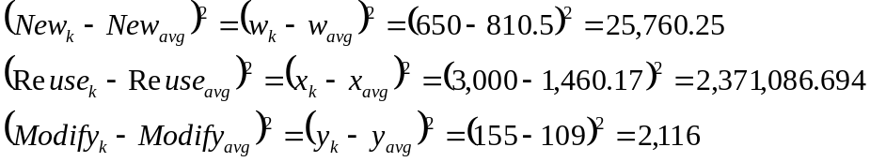  - Use program 6 to find the value of x, where p = 0.35 with n- 4 degrees of freedom for the t distribution. In this case, t(0.35,dof) = 1.386.  - Evaluate the square root.  - The final estimate is as follows.  z = 6.71+0.0784*650+0.0150*3,000+0.2461*155  = 140.902 hours  - The prediction interval of 38.846 hours means that the estimate is between 102.1 and 179.7 hours.

The gauss method

The gauss method | A frequently occurring problem in scientific engineering and business applications is to solve a system of N equations with N unknowns.  Gaussian elimination is a commonly used algorithm for solving these equations.  The Gauss method converts this  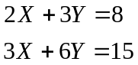  to this  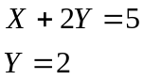 This technique is called triangularization.  What is the value of X?

Gauss method example | Solve this system.  The pivot [Row 1, Col 1]  - The equation with the largest absolute coefficient in the pivot column [any row, col 1] is exchanged with the equation in the pivot row.  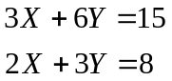  - Reduce the coefficient for the pivot term to 1 by multiplying through by the reciprocal of the coefficient.  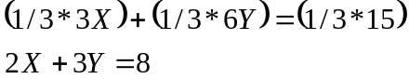  We now have  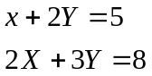
Continued on next page
The gauss method, Continued

The gauss method, continued | - Eliminate the pivot column terms in all rows below the pivot row  - Multiply the pivot row by the negated coefficient of the row below the pivot term to be eliminated, -2 in this example.  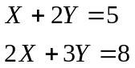 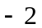 *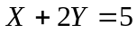 = 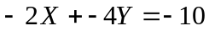  Note: don’t change the pivot row; put this result in a temp store.  - Add the 3a result to the row being eliminated.  - Repeat 3a and 3b for each row below the pivot term.  + = 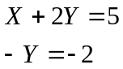 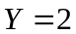  - Complete the triangularization by repeating steps 1 to 3 as needed, then solve for the remaining terms using back-substitution.  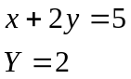  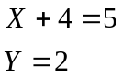  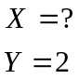
Continued on next page
The gauss method, Continued

The gauss algorithm | On a computer, the equations are represented by a matrix of the coefficients.  The algorithm is the same.  Given
  X | Y
  2 | 3 | 8
  3 | 6 | 15
  X | Y
  2 | 3 | 8
  3 | 6 | 15
  X | Y
  3 | 6 | 15
  2 | 3 | 8
  X | Y
  1 | 2 | 5
  2 | 3 | 8
  X | Y
  1 | 2 | 5
  0 | -1 | -2
  X | Y
  1 | 2 | 5
  0 | 1 | 2
  X | Y
  1 | 2 | 5 | X=1
  0 | 1 | 2 | Y=2
Continued on next page
The gauss method, Continued

A gauss algorithm | 1. I = 1  2. LET P=A_{K} , I = max{|A_{J,I}| : I <= J <= N} (Find the pivot value which is the largest number in the column below the I,I position.)  3. IF P = 0 THEN EXIT (If the remainder of this column is zero, a unique solution does not exist.)  4. IF K > I THEN FOR J = I TO N + 1 SWAP A(I,J) AND A(K,J) (Get the pivot value into the I,I position.)  5. FOR J = I + 1 TO N + 1 LET A_{I,J} = A_{I,J} / A_{I,I} (Get a one in the I,I position.) SET A_{I,I} = 1.  6. FOR L = I + 1 to N multiply row I by -A_{L,I} and add to row L (Zero out the column below the I,I position.)  7. I = I + 1. IF I < N THEN GO TO 2.  8. EXIT to back-substitution

Assignment instructions

Assignment instructions | Before starting program 8, review the top-level PSP2.1 process script below to ensure that you understand the “big picture” before you begin. Also, ensure that you have all of the required inputs before you begin the planning phase.

PSP2.1 Process Script

Purpose | To guide the development of module-level programs
Entry Criteria | - Problem description  - PSP2.1 Project Plan Summary form  - Size Estimating template  - Historical size and time data (estimated and actual)  - Time and Defect Recording logs  - Defect Type, Coding, and Size Counting standards  - Stopwatch (optional)

Step | Activities | Description
1 | Planning | - Produce or obtain a requirements statement.  - Use the PROBE method to estimate the added and modified size and the size prediction interval of this program.  - Complete the Size Estimating template.  - Use the PROBE method to estimate the required development time and the time prediction interval.  - Complete a Task Planning template.  - Complete a Schedule Planning template.  - Enter the plan data in the Project Plan Summary form.  - Complete the Time Recording log.
2 | Development | - Design the program.  - Document the design in the design templates.  - Review the design, and fix and log all defects found.  - Implement the design.  - Review the code, and fix and log all defects found.  - Compile the program, and fix and log all defects found.  - Test the program, and fix and log all defects found.  - Complete the Time Recording log.
3 | Postmortem | Complete the Project Plan Summary form with actual time, defect, and size data.

Exit Criteria | - A thoroughly tested program  - Completed Project Plan Summary form with estimated and actual data  - Completed Size Estimating and Task and Schedule Planning templates  - Completed Design templates  - Completed Design Review and Code Review checklists  - Completed Test Report template  - Completed PIP forms  - Completed Time and Defect Recording logs

Continued on next page
Assignment instructions, Continued

Planning  phase | Plan program 8 following the PSP2.1 planning phase and the PROBE estimating scripts.

PSP2.1 Planning Script

Purpose | To guide the PSP planning process
Entry Criteria | - Problem description  - PSP2.1 Project Plan Summary form  - Size Estimating, Task Planning, and Schedule Planning templates  - Historical size and time data (estimated and actual)  - Time Recording log

Step | Activities | Description
1 | Program  Requirements | - Produce or obtain a requirements statement for the program.  - Ensure that the requirements statement is clear and unambiguous.  - Resolve any questions.
2 | Size  Estimate | - Produce a program conceptual design.  - Use the PROBE method to estimate the added and modified size of this program.  - Complete the Size Estimating template and Project Plan Summary form.  - Calculate the 70% size prediction interval. ((Note: This step is completed by the SEI student workbook.)
3 | Resource  Estimate | - Use the PROBE method to estimate the time required to develop this program.  - Calculate the 70% size prediction interval. ((Note: This step is completed by the SEI student workbook)  - Using the To Date % from the most recently developed program as a guide, distribute the development time over the planned project phases. (Note: This step is completed by the SEI student workbook.)
4 | Task and  Schedule Planning | For projects lasting several days or more, complete the Task Planning and Schedule Planning templates.
5 | Defect  Estimate | - Based on your to-date data on defects per added and modified size unit, estimate the total defects to be found in this program.  - Based on your To Date % data, estimate the number of defects to be injected and removed by phase.

Exit Criteria | - Documented requirements statement  - Program conceptual design  - Completed Size Estimating template  - For projects lasting several days or more, completed Task and Schedule Planning templates  - Completed Project Plan Summary form with estimated program size, development time, and defect data, and the time and size prediction intervals  - Completed Time Recording log

Verify that you have met all of the exit criteria for the planning phase, then have an instructor review your plan. After your plan has been reviewed, proceed to the development phase.
Continued on next page

Assignment instructions, Continued
Use the PROBE method to create size and resource estimates.

PROBE Estimating Script

Purpose | To guide the size and time estimating process using the PROBE method
Entry Criteria | - Requirements statement  - Size Estimating template and instructions  - Size per item data for part types  - Time Recording log  - Historical size and time data
General | - This script assumes that you are using added and modified size data as the size-accounting types for making size and time estimates.  - If you choose some other size-accounting types, replace every “added and modified” in this script with the size-accounting types of your choice.

Step | Activities | Description
1 | Conceptual Design | Review the requirements and produce a conceptual design.
2 | Parts Additions | Follow the Size Estimating Template instructions to estimate the parts additions and the new reusable parts sizes.
3 | Base Parts and Reused Parts | - For the base program, estimate the size of the base, deleted, modified, and added code.  - Measure and/or estimate the size of the parts to be reused.
4 | Size Estimating Procedure | - If you have sufficient estimated proxy size and actual added and modified size data (three or more points that correlate), use procedure 4A.  - If you do not have sufficient estimated data but have sufficient plan added and modified and actual added and modified size data (three or more points that correlate), use procedure 4B.  - If you have insufficient data or they do not correlate, use procedure 4C.  - If you have no historical data, use procedure 4D.
4A | Size Estimating Procedure 4A | - Using the linear-regression method, calculate the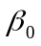and 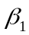 parameters from the estimated proxy size and actual added and modified size data.  - If the absolute value ofis not near 0 (less than about 25% of the expected size of the new program), or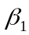is not near 1.0 (between about 0.5 and 2.0), use procedure 4B.
4B | Size Estimating Procedure 4B | - Using the linear-regression method, calculate theandparameters from the plan added and modified size and actual added and modified size data.  - If the absolute value of is not near 0 (less than about 25% of the expected size of the new program), oris not near 1.0 (between about 0.5 and 2.0), use procedure 4C.
4C | Size Estimating Procedure 4C | If you have any data on plan added and modified size and actual added and modified size, set= 0 and = (actual total added and modified size to date/plan total added and modified size to date).
4D | Size Estimating Procedure 4D | If you have no historical data, use your judgment to estimate added and modified size.
(continued)

Continued on next page

Assignment instructions, Continued
PROBE Estimating Script (Continued)

Step | Activities | Description
5 | Time Estimating Procedure | - If you have sufficient estimated proxy size and actual development time data (three or more points that correlate), use procedure 5A.  - If you do not have sufficient estimated size data but have sufficient plan added and modified size and actual development time data (three or more points that correlate), use procedure 5B.  - If you have insufficient data or they do not correlate, use procedure 5C.  - If you have no historical data, use procedure 5D.
5A | Time Estimating Procedure 5A | - Using the linear-regression method, calculate theand parameters from the estimated proxy size and actual total development time data.  - Ifis not near 0 (substantially smaller than the expected development time for the new program), oris not within 50% of 1/(historical productivity), use procedure 5B.
5B | Time Estimating Procedure 5B | - Using the linear-regression method, calculate theand regression parameters from the plan added and modified size and actual total development time data.  - Ifis not near 0 (substantially smaller than the expected development time for the new program), oris not within 50% of 1/(historical productivity), use procedure 5C.
5C | Time Estimating Procedure 5C | - If you have data on estimated – added and modified size and actual development time, set= 0 and = (actual total development time to date/estimated – total added and modified size to date).  - If you have data on plan – added and modified size and actual development time, set= 0 and = (actual total development time to date/plan total added and modified size to date).  - If you only have actual time and size data, set= 0 and = (actual total development time to date/actual total added and modified size to date).
5D | Time Estimating Procedure 5D | If you have no historical data, use your judgment to estimate the development time from the estimated added and modified size.
6 | Time and Size Prediction Intervals | - If you used regression method A or B, calculate the 70% prediction intervals for the time and size estimates.  - If you did not use the regression method or do not know how to calculate the prediction interval, calculate the minimum and maximum development time estimate limits from your historical maximum and minimum productivity for the programs written to date.

Exit Criteria | - Completed estimated and actual entries for all pertinent size categories  - Completed PROBE Calculation Worksheet with size and time entries  - Plan and actual values entered on the Project Plan Summary
Continued on next page
Assignment instructions, Continued

Development phase | Develop the program following the PSP2.1 development phase script.
PSP2.1 Development Script
Purpose | To guide the development of small programs
Entry Criteria | - Requirements statement  - Project Plan Summary form with estimated program size and development time  - For projects lasting several days or more, completed Task Planning and Schedule Planning templates  - Time and Defect Recording logs  - Defect Type standard and Coding standard

Step | Activities | Description
1 | Design | - Review the requirements and produce an external specification to meet them.  - Complete Functional and Operational Specification templates to record this specification.  - Produce a design to meet this specification.  - Record the design in Functional, Operational, State, and Logic Specification templates.  - Record in the Defect Recording log any requirements defects found.  - Record time in the Time Recording log.
2 | Design  Review | - Follow the Design Review script and checklist and review the design.  - Fix all defects found.  - Record defects in the Defect Recording log.  - Record time in the Time Recording log.
3 | Code | - Implement the design following the Coding standard.  - Record in the Defect Recording log any requirements or design defects found.  - Record time in the Time Recording log.
4 | Code  Review | - Follow the Code Review script and checklist and review the code.  - Fix all defects found.  - Record defects in the Defect Recording log.  - Record time in the Time Recording log.
5 | Compile | - Compile the program until there are no compile errors.  - Fix all defects found.  - Record defects in the Defect Recording log.  - Record time in the Time Recording log.
6 | Test | - Test until all tests run without error.  - Fix all defects found.  - Record defects in the Defect Recording log.  - Record time in the Time Recording log.  - Complete a Test Report template on the tests conducted and the results obtained.

Exit Criteria | - A thoroughly tested program that conforms to the Coding standard  - Completed Design templates  - Completed Design Review and Code Review checklists  - Completed Test Report template  - Completed Time and Defect Recording logs

Verify that you have met all of the exit criteria for the development phase, then proceed to the postmortem phase.
Continued on next page
Assignment instructions, Continued

 | Design  review |  | Review your designs following the PSP2.1 design review script.
PSP2.1 Design Review Script

 |  | Purpose |  | To guide you in reviewing detailed designs
 |  | Entry Criteria |  | - Completed program design documented with the PSP Design templates  - Design Review checklist  - Design standard  - Defect Type standard  - Time and Defect Recording logs
 |  | General |  | Where the design was previously verified, check that the analyses  - covered all of the design  - were updated for all design changes  - are correct  - are clear and complete

Step | Activities | Description
1 | Preparation | - Examine the program and checklist and decide on a review strategy.  - Examine the program to identify its state machines, internal loops, and variable and system limits.  - Use a trace table or other analytical method to verify the correctness of the design.
2 | Review | - Follow the Design Review checklist.  - Review the entire program for each checklist category; do not try to review for more than one category at a time!  - Check off each item as you complete it.  - Complete a separate checklist for each product or product segment reviewed.
3 | Fix Check | - Check each defect fix for correctness.  - Re-review all changes.  - Record any fix defects as new defects and, where you know the defective defect number, enter it in the fix defect space.

Exit Criteria | - A fully reviewed detailed design  - One or more Design Review checklists for every design reviewed  - Documented design analysis results  - All identified defects fixed and all fixes checked  - Completed Time and Defect Recording logs

Continued on next page
Assignment instructions, Continued

 | Code  review |  | Review your code following the code review script.
Code Review Script

 |  | Purpose |  | To guide you in reviewing programs
 |  | Entry Criteria |  | - A completed and reviewed program design  - Source program listing  - Code Review checklist  - Coding standard  - Defect Type standard  - Time and Defect Recording logs
 |  | General |  | Do the code review with a source-code listing; do not review on the screen!

Step | Activities | Description
1 | Review | - Follow the Code Review checklist.  - Review the entire program for each checklist category; do not try to review for more than one category at a time!  - Check off each item as it is completed.  - For multiple procedures or programs, complete a separate checklist for each.
2 | Correct | - Correct all defects.  - If the correction cannot be completed, abort the review and return to the prior process phase.  - To facilitate defect analysis, record all of the data specified in the Defect Recording log instructions for every defect.
3 | Check | - Check each defect fix for correctness.  - Re-review all design changes.  - Record any fix defects as new defects and, where you know the number of the defect with the incorrect fix, enter it in the fix defect space.

Exit Criteria | - A fully reviewed source program  - One or more Code Review checklists for every program reviewed  - All identified defects fixed  - Completed Time and Defect Recording logs
Continued on next page
Assignment instructions, Continued

Postmortem  phase | Conduct the postmortem following the PSP2.1 postmortem script.

PSP2.1 Postmortem Script

Purpose | To guide the PSP postmortem process
Entry Criteria | - Problem description and requirements statement  - Project Plan Summary form with program size, development time, and defect data  - For projects lasting several days or more, completed Task Planning and Schedule Planning templates  - Completed Test Report template  - Completed Design templates  - Completed Design Review and Code Review checklists  - Completed Time and Defect Recording logs  - A tested and running program that conforms to the coding and size counting standards

Step | Activities | Description
1 | Defect Recording | - Review the Project Plan Summary to verify that all of the defects found in each phase were recorded.  - Using your best recollection, record any omitted defects.
2 | Defect Data Consistency | - Check that the data on every defect in the Defect Recording log are accurate and complete.  - Verify that the numbers of defects injected and removed per phase are reasonable and correct.  - Determine the process yield and verify that the value is reasonable and correct.  - Using your best recollection, correct any missing or incorrect defect data.
3 | Size | - Count the size of the completed program.  - Determine the size of the base, deleted, modified, base additions, reused, new reusable code, and added parts.  - Enter these data in the Size Estimating template.  - Determine the total program size  - Enter this data in the Project Plan Summary form.
4 | Time | - Review the completed Time Recording log for errors or omissions.  - Using your best recollection, correct any missing or incomplete time data.

Exit Criteria | - A thoroughly tested program that conforms to the coding and size counting standards  - Completed Design templates  - Completed Design Review and Code Review checklists  - Completed Test Report template  - Completed Project Plan Summary form  - Completed PIP forms describing process problems, improvement suggestions, and lessons learned  - Completed Time and Defect Recording logs

Verify that you have met all of the exit criteria for the PSP2.1 postmortem phase, then submit your assignment.
Continued on next page
Assignment instructions, Continued

Submitting your assignment | When you’ve completed the postmortem phase, submit your assignment package, source code, and test results to the instructor.  The order for the assignment package is  • PSP2.1 Project Plan Summary form  • Test Report template  • PSP2.1 Design Review checklist  • Code Review checklist  • PIP form  • Size Estimating template  • PROBE Calculation worksheet  • Operational Specification template  • Functional Specification template  • State Specification template  • Logic Specification template  • Time Recording log  • Defect Recording log  • source program listing  • test results

Guidelines and evaluation criteria for program 8

Evaluation  criteria | Your process report must be  • complete  • legible  • in the specified order | Your process data must be  • accurate  • precise  • self-consistent

Suggestions | Remember, you should complete this assignment today.  Keep your programs simple. You will learn as much from developing small programs as from large ones.  If you are not sure about something, ask your instructor for clarification.  Software is not a solo business, so you do not have to work alone.  - You must, however, produce your own estimates, designs, code, and completed forms and reports.  - You may have others review your work, and you may change it as a result.  - You should note any help you receive from others in your process report. Log the review time that you and your associates spend, and log the defects found or any changes made.

Operational Specification Template
Student |  | Date
Program |  | Program #
Instructor |  | Language

Scenario Number |  | User Objective
Scenario Objective
Source | Step | Action |  | Comments

Operational Specification Template Instructions
Purpose | - To hold descriptions of the likely operational scenarios followed during program use  - To ensure that all significant usage issues are considered during program design  - To specify test scenarios
General | - Use this template for complete programs, subsystems, or systems.  - Group multiple small scenarios on a single template, as long as they are clearly distinguished and have related objectives.  - List the major scenarios and reference other exception, error, or special cases under comments.  - Use this template to document the operational specifications during planning, design, test development, implementation, and test.  - After implementation and testing, update the template to reflect the actual implemented product.
Header | - Enter your name and the date.  - Enter the program name and number.  - Enter the instructor’s name and the programming language you are using.
Scenario Number | Where several scenarios are involved, reference numbers are needed.
User Objective | List the users’ likely purpose for the scenario, for example, to log onto the system or to handle an error condition.
Scenario Objective | List the designer’s purpose for the scenario, for example, to define common user errors or to detail a test scenario.
Source | - Enter the source of the scenario action.  - Example sources could be user, program, and system.
Step | Provide sequence numbers for the scenario steps. These facilitate reviews and inspections.
Action | Describe the action taken, such as  - Enter incorrect mode selection.  - Provide error message.
Comments | List significant information relating to the action, such as  - User enters an incorrect value.  - An error is possible with this action.

Functional Specification Template
Student |  |  |  |  | Date
Program |  |  |  |  | Program #
Instructor |  |  |  |  | Language
Class Name
Parent Class
Attributes
 | Declaration |  |  | Description
Items
 | Declaration |  |  | Description

Functional Specification Template Instructions
Purpose | - To hold a part’s functional specifications  - To describe classes, program modules, or entire programs
General | - Use this template for complete programs, subsystems, or systems.  - Use this template to document the functional specifications during planning, design, test development, implementation, and test.  - After implementation and testing, update the template to reflect the actual implemented product.
Header | - Enter your name and the date.  - Enter the program name and number.  - Enter the instructor’s name and the programming language you are using.
Class Name | - Enter the part or class name and the classes from which it directly inherits.  - List the class names starting with the most immediate.  - Where practical, list the full inheritance hierarchy.
Attributes | - Provide the declaration and description for each global or externally visible variable or parameter with any constraints.  - List pertinent relationships of this part with other parts together with the multiplicity and constraints.
Items | - Provide the declaration and description for each item.  - Precisely describe the conditions that govern each item’s return values.  - Describe any initialization or other key item responsibilities.
Example Items | An item could be a class method, procedure, function, or database query, for example.

State Specification Template
Student |  |  |  |  | Date
Program |  |  |  |  | Program #
Instructor |  |  |  |  | Language
State Name |  |  |  | Description
Function/Parameter |  |  |  | Description
States/Next States |  |  |  | Transition Condition |  | Action

State Specification Template Instructions
Purpose | - To hold the state and state transition specifications for a system, class, or program  - To support state-machine analysis during design, design reviews, and design inspections
General | - This form shows each system, program, or routine state, the attributes of that state, and the transition conditions among the states.  - Use this template to document the state specifications during planning, design, test development, implementation, and test.  - After implementation and testing, update the template to reflect the actual implemented product.
Header | - Enter your name and the date.  - Enter the program name and number.  - Enter the instructor’s name and the programming language you are using.
State Name | - Name all of the program’s states.  - Also enter each state name in the header space at the top of each “States/Next States” section of the template.
State Name Description | - Describe each state and any parameter values that characterize it.  - For example, if a state is described by SetSize=10 and SetPosition=3, list SetSize=10 and SetPosition=3.
Function/Parameter | - List the principal functions and parameters.  - Include all key variables or methods used to define state transitions or actions.
Function/Parameter Description | - For each function, provide its declaration, parameters, and returns.  - For each parameter, define its type and significant values.
Next State | - For each state, list the names of all possible next states.  - Include the state itself.
Transition Condition | List the conditions for transition to each next state.  - Use a mathematical or otherwise precise notation.  - If the transition is impossible, list "impossible," with a note saying why.
Action | List the actions taken with each state transition.

Logic Specification Template
Student |  | Date
Program |  | Program #
Instructor |  | Language

Design
References

Parameters

Logic Specification Template Instructions
Purpose | - To contain the pseudocode for a program, component, or system  - To enable precise and complete program implementation  - To facilitate thorough design and implementation reviews and inspections
General | - Use this template to document the program’s detailed logic.  - After implementation and testing, update the template to reflect the actual implemented product.  - During detailed design, write the pseudocode needed to describe all of the program’s logic.  - Use plain language and avoid using programming instructions wherever practical.
Header | - Enter your name and the date.  - Enter the program name and number.  - Enter the instructor’s name and the programming language you are using.
Design References | List the references used to produce the program’s logical design.  - the Operational, Functional, and State templates  - the program’s requirements  - any other pertinent source
Parameters | - Where needed, define any parameters or abbreviations used.  - Avoid duplicating definitions on other templates and reference these other definitions where they are needed.

